**433 MHz TX/RX Module**

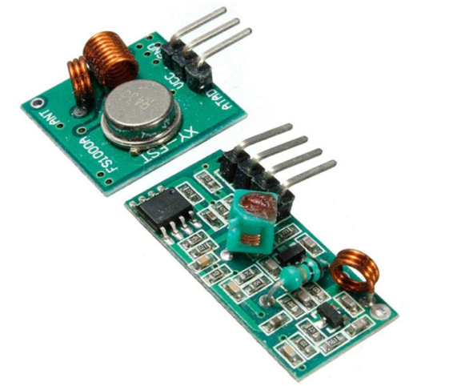

**Internal Circuitry**

Receiver:

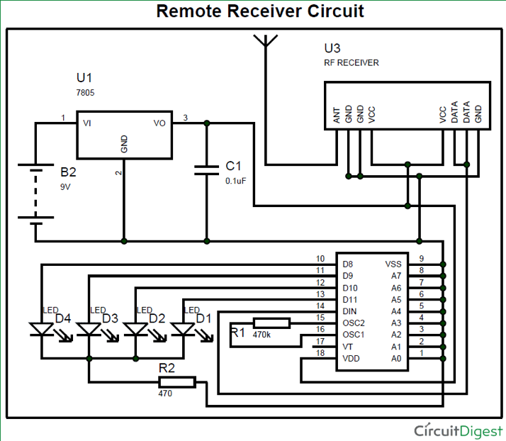

Transmitter:

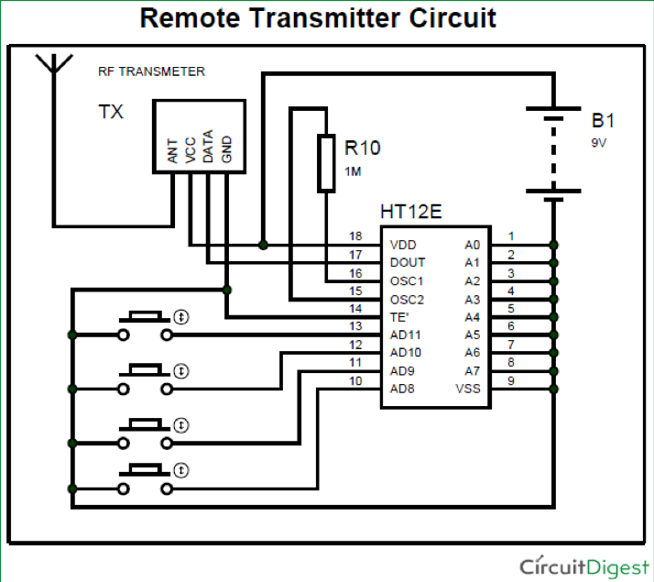

The wireless TX/RX modules transmit information over the 433 MHz wireless spectrum band. Performance is unreliable at best, with some tests yielding effective data transfer across the width of a lab table whereas in other instances the modules would be virtually touching in order for a connection to be consistently received. Allegedly, some modules are capable of up to 90m of range, though this requires a very slow transmission rate to maintain a stable connection and is subject to environmental factors. Out of line of sight, transmission is poor if not negated entirely. Determining effective range is further complicated by the module's reliance on a wire to be used as an antenna. Even with the addition of an antenna, performance improvements were sporadic and random.

These modules transmit using the ASK protocol (Amplitude Shift Keying). This system transmits indiscriminately to all devices within range with no retransmit or acknowledgement of transmission, but uses 4-6 bit encoding as default. Each module has one dedicated 5V pin and one GND pin as well as one DATA pin (Diagrams may include additional pins in depiction of module).

The RadioHead open source library supports many inexpensive transmission devices including these modules. Drivers for the communication between the Arduino Nano and base Arduino Uno unit relied on library functions implemented within this external library.

**Internal Circuitry**